VIETNAM NATIONAL UNIVERSITY, HO CHI MINH CITY
UNIVERSITY OF TECHNOLOGY
FACULTY OF COMPUTER SCIENCE AND ENGINEERING

COMPUTER ARCHITECHTURE – CO2008
Assignment (Semester: 251)
FILTERING AND PREDICTION SIGNAL
WITH WIENER FILTER
Advisor: Nguyễn Thành Lộc
Student(s): Võ Thiện Toàn - 2453265 (CC05)

Ho Chi Minh City, October 2025

Introduction

The Wiener Filter is s recognized as a classic adaptive filtering technique within the field of signal processing. The fundamental objective of this filter is to estimate a desired signal $s(n)$, from an observed input signal $x(n)$, that has been contaminated by noise or interference $w(n)$. Generally, the input signal $x(n)$ is the summation of the desired signal $s(n)$ and the undesired noise $w(n)$. The system is designed to suppress the additive interference while simultaneously preserving the essential characteristics of the desired signal $s(n)$.
The core principle used for optimizing the filter impulse response $h(n)$, is the minimization of the mean-square error (MMSE). This criterion is favored due to its simplicity and mathematical tractability. The optimum linear filter, defined by the criterion of MMSE is referred to as a Wiener Filter. The theoretical derivation of the MMSE involves the use of derivatives and relates directly to the Principle of orthogonality. The set of linear equations utilized to determine the optimized coefficients $h(k)$, are known as the Wiener-Hopf equations.
The general linear estimation problem distinguishes three special cases:
- $d(n)=s(n)$
- $d(n)=s(n+D)$ (signal predication)
- $d(n)=s(n-D)$ (signal smoothing)
The final MMSE achieved by the Wiener Filter is expressed mathematically in relation to the variance of the desired signal $σ_{d}^{2}$ and the optimized filter coefficients $h_{opt}(k)$.
In real-world applications, the input signal $x(n)$ is the sum of desired signal $s(n)$ and an interference or noise signal $w(n)$. The Wiener Filter is tasked with finding the optimal set of filter coefficients $h_{opt}$ such that the output signal $y(n)$ approximates the desired signal $d(n)$ as closely as possible.
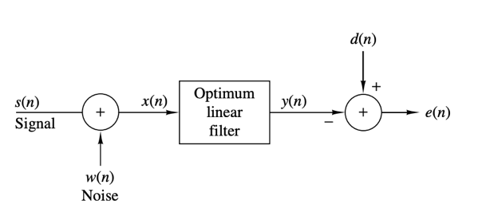
Fig.1: An example of Wiener Filter Linear Optimum Filtering

Theoretical background

Principle of orthogonality: In statistics and signal processing, the orthogonality principle is a necessary and sufficient condition for the optimality of a Bayesian estimator. Loosely stated, the orthogonality principle says that the error vector of the optimal estimator (in a mean square error sense) is orthogonal to any possible estimator. The orthogonality principle is most commonly stated for linear estimators, but more general formulations are possible. Since the principle is a necessary and sufficient condition for optimality, it can be used to find the minimum mean square error estimator.
Gaussian Elimination (row reduction): a mathematical algorithm for solving systems of linear equations by using a sequence of elementary row operations on the augmented matrix to transform it into upper triangular matrix form.
- The core objective: the goal is to find the unique set of optimal filter coefficients $h=[h_{0},h_{1},...,h_{M-1}]^{T}$, that satisfies the linear system derived from minimizing the MMSE:
$$A∙x=B$$Where $A=R_{M}$ (Autocorrelation Matrix) and $B=γ_{d}$ (Cross-correlation Vector)
- Forward elimination: the objective of this phase is to transform the system matrix $A$ into an upper triangular matrix. This mean all elements below the main diagonal are eliminated (set to zero). his process is executed iteratively, pivoting on the diagonal elements $A\left[k\right]\left[k\right]$.
- Process: For every pivot row $k$ (from 0 to $M-2$), the algorithm iterates through all rows $i$ below it $(i=k+1 to M-1)$.
- Factor: A multiplier is calculated for each row $i$: $Factor=\frac{A[i][k]}{A[k][k]}$
- Row operation: Row $k$ is used to eliminate the non-zero element $A[i][k]$. This operation is applied to the entire row $i$ and to the corresponding element $B[i]:$
$New A[i][j]=A[i][j]-Factor×A[k][j]$
$New B[i]=B[i]-Factor×B[k]$
- Back substitution: Once the matrix $A$ is in upper triangular form, the system is much easier to solve. We can start from the bottom equation (which has only one unknown) and substitute the solution upwards.
$$h_{i}=\frac{B[i]-\sum_{j=i+1}^{M-1}{(A[i][j]∙h_{j})}}{A[i][i]}$$
System Definition and Output (Formula 1): The filter operates on an input signal $x(n)$ of finite length N and use a sets of coefficients $h$, where M is the filter order.
- Output signal: The output $Y(n)$ is a linear convolution of the input signal and the filter coefficients.
$$y\left(n\right)=\sum_{k=0}^{M-1}{h_{k}x\left(n-k\right)} (Formula 1)$$
- $y(n): Output signal that the filter calculated$
- $h_{k}: Optimal filter coefficients$
- $M: The length of the filter$
- $k: Time lag, ranging from 0 to M-1 (0 ≤k≤M-1)$
- $x(n-k): The value of the input signal at a delay of k and current time$
- We can express the output $y(n)$ as a linear combination of the input sequence $h_{0}x(n)+h_{1}x(n-1)+h_{2}x(n-2)+....+h_{M-1}x(n-M+1)$. This expasion explicitly demostrates the memory structure of the filter.
- These coefficients acts as optimal weights basd on statistical mechanisms, effectively amplifying highly correlated signal components while suppressing uncorrelated random noise. Consequently, $y(n)$ represents the optimal estimate of the desired signal, minimizing the estimation error.
Mean-square value of the error (Formula 2): it represents the cost function that the Wiener Filter algorithm must minimize. It is the core mathematical expression that defines what it means for the filter to be "optimal".
$$E_{M}=E\left[{|e(n)|}^{2}\right]=E{\left|D(n)-\sum_{k=0}^{M-1}{h_{k}x(n-k)}\right|}^{2}(Formula 2)$$
- $E_{M}(MSE):$ The single numerical quantity that the entire Wiener filter calculation aims to minimize.
- $e(n):$ Instantaneous Error at time $n (e(n)=d(n)-y(n))$
- $E:$ Expectation (Mean or Average), this operator takes the average of the squared error over time (or across all available data samples $N$). It transforms the instantaneous error into a single, reliable measure of filter performance.

- The goal of the Wiener filter is to find the set of filter coefficients $h=\left[h_{0},h_{1},…,h_{M-1}\right]$
that drives the value of $E_{M}$ to its minimum possible point. Mathematically, this minimization is achieved by performing partial differentiation of $E_{M}$ with respect to each filter coefficient $h_{k}$ and setting the result to zero:
$$\frac{∂E_{M}}{∂h_{k}}=0, for k=0, 1, 2, ..., M-1$$
This process is based on the Principle of Orthogonality, which states that the residual error must be uncorrelated (orthogonal) to the input data used to compute it.
- Formula (2) is not directly calculated in MIPS program (since the goal is to find the minimum point, not the MSE itself). Instead, it serves as the starting point for the entire theoretical derivation:
- Substitute (1) into (2): The right-hand side of Formula (2) is obtained by substituting the definition of the output $y(n)$ (Formula 1) into the error term.
- Differentiate: When the resulting quadratic function of the coefficients is differentiated and set to zero, the final algebraic result is the Wiener-Hopf Equation (Formula 4).
$$Differentiating (2) →Result in R_{M}h=γ_{d}$$
- Thus, Formula (2) is the cost function that mathematically justifies the subsequent requirement to solve Formula (4).
Wiener-Hopf Summation Formula (Formula 4): is the compact and definitive representation of the system you must solve to find the optimal filter. It translates the statistical relationships into a standard linear algebra problem.
The equation is concisely stated as:
$$R_{M}h=γ_{d}$$
When expanded to show the constituent vectors and matrix (based on $M$, the filter order), the relationship becomes clear:
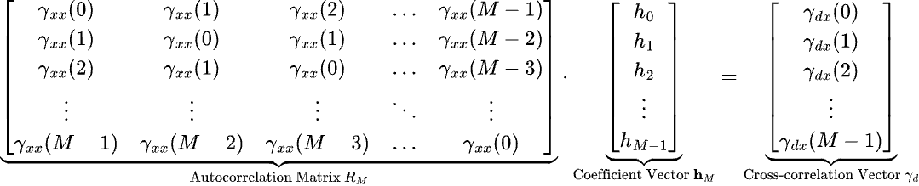

- Matrix $R_{M}$
- Autocorrelation Matrix (of the input signal $x(n)$).
- Size $M×M$.
- Consists of the autocorrelation value $γ_{xx}(k)$ calculated in Formula (a).
- This is the matrix $A$ in the Gaussian Elimination solver.
- Vector $h_{M}$
- Filter Coefficient Vector.
- Size $M×1$.
- The unkown values $h_{0}$ through $h_{M-1}$ that defined the optimal filter.
- This is the vector $x$ in the linear system solver.
- Vector $γ_{d}$
- Cross-correlation Vector.
- Size $M×1$.
- Consists of the cross-correlation values $γ_{d}(l)$ calculated in Formula (b).
- This vector links the desired behavior $(d)$ to the input signal statistics $(x)$, providing the necessary target for the system to aim for.
- This is the vector $B$ in Gaussian Elimination solver.
Autocorrelation Function (Formula a)
$γ_{xx}\left(k\right)=E\left[X\left(n\right)X\left(n-k\right)\right]$
- $Autocorrelation {(γ}_{xx})$: this function measure the correlation of the input signal with time-delayed version of itself.
- $Index k$: represents the time delay, or "lag," between the two copies of the signal being multiplied $(0≤k≤M-1)$.
- Autocorrelation characterizes the power spectrum and structure of the input signal. It tells the filter how predictable the noise and signal components are based on their past values.

Cross-correlation function (Formula b)
The cross-correlation function $γ_{dx}$ is the link between the desired outcome and the input data. It is essential because it provides the statistical intelligence needed to determine the filter coefficients.
$$γ_{dx}(k)=E\left[d(n)x(n-k)\right]$$
- Cross-correlation measures the degree of similarity between two different signals (desired outcome signal and inuput signal), as a function of time delay $k$.
- The filter needs to know how a shift in the noisy input $x(n-k)$ correlates with the ideal, clean output $d(n)$.
- The value $γ_{dx}(k)$ form the cross-correlation vector $γ_{d}$ on the right side of Wiener-Hopf equation.

